Chapter 6, Problem 19.

Find the equivalent capacitance between terminals a and b in the circuit of Fig. 6.53. All capacitances are in μF.

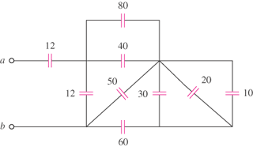

Figure 6.53
For Prob. 6.19.

